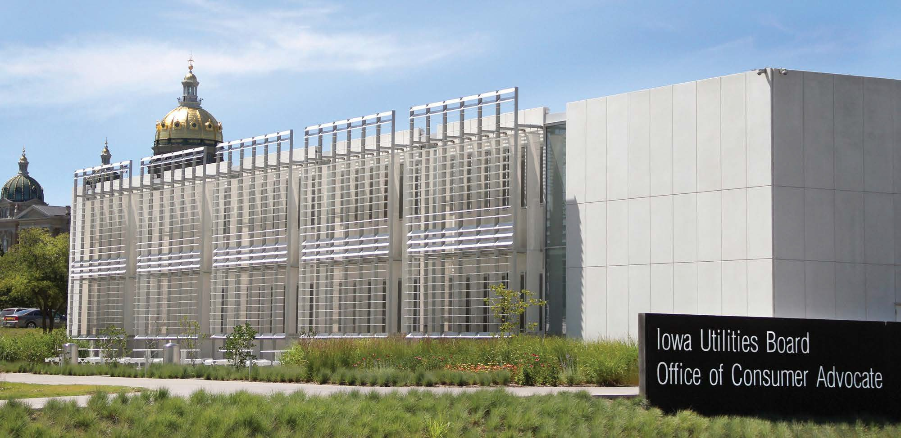

Iowa Utilities Board
1375 E. Court Ave.
Des Moines, IA 50319-0069
Email: iub@iub.iowa.gov

Agenda

- What is the Iowa Utilities Board (IUB)?
- Office of Consumer Advocate (OCA)
- Summary of the Franchise Process and the Legal Rights of Landowners (IUB Presentation)
- Project Information (Company Presentation)
- Question and Answer Session

Your Information Handout Includes:

- Agenda
- The IUB’s Informational Meeting Presentation
- Statement of Property Owner’s Rights
- Filing Instructions for IUB’s Electronic Filing System
- Suggested Form for Filing Objections
- Iowa Code Chapter 478
- Frequently Asked Questions about Eminent Domain

What is the Iowa Utilities Board?

- Independent Quasi-Judicial Regulatory Body
- Three Board Members
  - Serve staggered six-year terms
  - No more than two from the same political party
  - Appointed by the Governor
  - Confirmed by the Senate
- Current Board Members are:
  - Geri Huser (Chair)
  - Richard Lozier
  - Joshua Byrnes

What is the Iowa Utilities Board?

- The Board regulates the rates, safety, and service of utility companies. It is also charged with issuing permits for various types of energy infrastructure projects under Iowa law.
- Decisions are based on evidence and the law.
- Board actions may be reviewed by the courts.

Office of Consumer Advocate (OCA)

- The Office of Consumer Advocate is a division of the Iowa Department of Justice.
- OCA represents the general interests of consumers and the public in all matters brought before the IUB.
- For more information, see the sheet provided in your information handout.

The Franchise Process Overview

- A “franchise” is a grant of authority issued by the IUB.
- This informational meeting is required by Iowa law before the company can begin easement negotiations.
- The company cannot file its application (petition) with the IUB until at least 30 days after the last informational meeting.

The Franchise Process Overview

- A hearing is required if any objection(s) or request for eminent domain is filed with the IUB.
- A hearing is not required if no objection(s) or request for eminent domain is filed with the IUB.

Objections or Comments

- Phone calls or verbal communication will not be considered as part of the official record.
- Only written objections or comments will be considered.

- Reference the docket number E- objection or comment letters.
in your

- Objections or comments may be filed either electronically or by mail.
- A suggested objection form is included in the handout packet.

Public Hearing and Procedures

- If a hearing is required, the IUB sets a hearing date and encourages concerned landowners to participate at the hearing.
- In the case of a hearing, objections may be filed up until 20 days after the date of the last publication of the final notice.
- Before the filing deadline, landowners who objected to the project should file statements, testimony, evidence, and/or any other material that supports their position.
- The IUB and its staff cannot provide legal advice to landowners; however, staff can explain the process and hearing procedures.

Easements

- An easement agreement is a legal document that provides rights to a company to locate an electric line on private property.
- An easement does not transfer ownership of the property.
- Landowners may contact an attorney to assist in negotiation of the easement terms.
- An easement may be either voluntary or obtained through the use of eminent domain.

Eminent Domain (Condemnation)

- The right of eminent domain may only be granted by the IUB after a public hearing.
- Notice of the IUB hearing will be sent by the utility company through registered mail to landowners for whom eminent domain is requested.
- If the IUB grants eminent domain the company may obtain easement rights after a condemnation proceeding.
- The County Compensation Commission under Iowa Code 6B determines just compensation for property rights taken by eminent domain.
- FAQs about eminent domain are included in the handout packet.

Statement of Property Owner’s Rights

The Statement of Property Owner’s Rights pursuant to Chapter 34 of the Iowa Attorney General’s rules is the green sheet in the information handout.

Contact Information

Iowa Utilities Board
1375 E. Court Ave.
Des Moines, IA 50319-0069
Phone: 515-725-7300
Email: iub@iub.iowa.gov
Website: iub.iowa.gov

